Plead the Blood Of The Lamb, there is power in the blood!

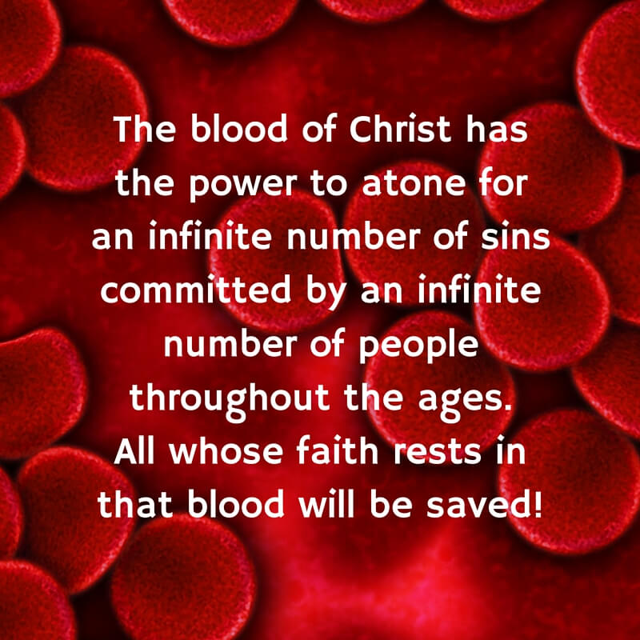

Prayer Targets
  - For Weekly Corporate Prayer
Gideon Warriors | 2020| War Room

Renew, Revive, Restore, Replenish, Rebuild, Refresh, Recover, Reform
Prayer For the 7 Continents
- Asia.
- Africa.
- North America.
- South America.
- Antarctica.
- Europe.
- Australia.

Pray for salvation, redemption, deliverance, and relationship with Christ Jesus

Pray for all governmental authorities. Scripture commands us
to pray for all who are in high positions, “that we may lead a peaceful
and quiet life, godly and dignified in every way” (1 Timothy 2:2). The
President needs our prayers. So do the presidential candidates. We
need to pray for our senators, congressmen, governors, mayors, and
city councilmen. Most especially, let us pray for police officers who are
on the front lines of the tension in our cities. Pray they would protect
and serve with justice, compassion, and wisdom. Also include Prime
Ministers, Presidents and Leaders from other countries.

Pray for suffering and mourning families. The families of world
need our prayers, as well the families of the Middle East and war-torn
areas. The families of China that have fallen to slavery, imprisonment,
and slave labor. Those that are trying to help humanity from this bondage,
slavery, captivity, and horror need our prayers. As well as the families
of the child sex trafficking rings who children have been missing and
the children who need a miracle and way od escape. With Christian
love and sympathy, me must pray for all who have been directly affected
by the horrendous crimes done against humanity.

Pray for an open door for the gospel. People need God. And they
can only find him through saving-faith in the blood and righteousness
of Jesus Christ. Pray that during these critical times, the Lord would
open a door for the gospel, so that lost people may hear and believe
the good news of Jesus Christ. In these dark times, may the light of
the gospel shines bright. May we as Christians be bold to share the
good news. And may many lost and weary souls find their way home
to God through faith in Christ.

Pray for the pains, hurts, unforgiveness and grief to be healed.
Emotional wounds have always been and remains a painful reality in
our country. Unfortunately, communication is something that can be a
problem concerning these areas, we often foolishly expect healing by
putting Band-Aids on the affliction. But true healing does not come from
changed laws, court verdicts, civil protests, more education, drugs, alcohol
or economic reform. The sin problem, lack of compassion and self-serving
ideas have brought so much heaviness on relationships, families and how
we see ourselves in this world. We can only be healed as the gospel
changes hearts and minds. The power of Christ to revive is strong and the
power to transform is mighty. Let us pray a revival in our day that leads to
faith, hope, trust, and a mighty healing for the nations. Love the Lord with
all you have and love for our neighbor.

Pray for local churches in troubled cities and around the
country. The world at its worst needs the church at its best.
The church of Acts was radical and thy went house to house to do
bible studies in homes. The big cities really need our prayers, they need
our brothers and sisters touching the hearts of those hard-hit areas. Saints as
you live, serve, and witness in the midst of these troubled communities,
stay in mercy, grace and peace. Pray for that are in service to the body and
for the unsaved. The same is true for churches in cities great or small throughout
the country and the world. Pray that the church would be the church, making
disciples, being the salt, sanctified in the Lord Jesus Christ making a difference
and inspiring change. Not compromising the most holy faith! (Matthew 28:18-20).

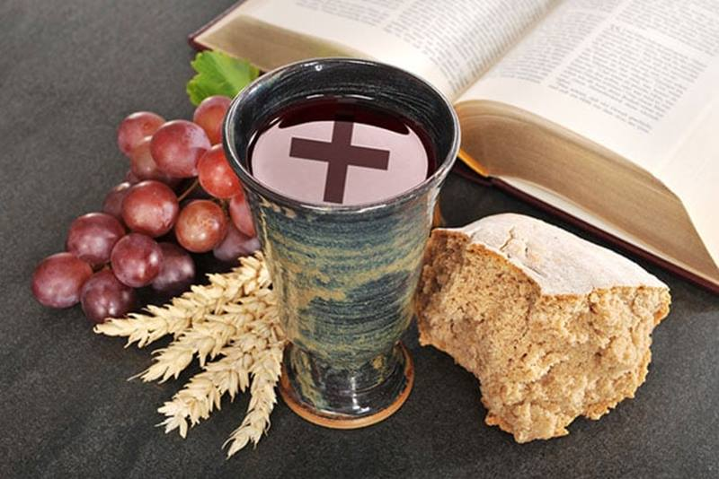

Pray for the Shiloh Church to be light and salt. Christ has called
us to be the salt of the earth and the light of the world. We are to let
our light shine before men, so that they may see our good works and
glorify the Father in heaven (Matthew 5:13-16). Pray for the Shiloh
Church (and every church) to faithfully declare the trust of Jesus Christ
and faithfully demonstrate the love of Jesus Christ. May the Lord use us
to influence our city with the gospel to the glory of God!

