Plead The Blood Of The Lamb, there is power in the blood!

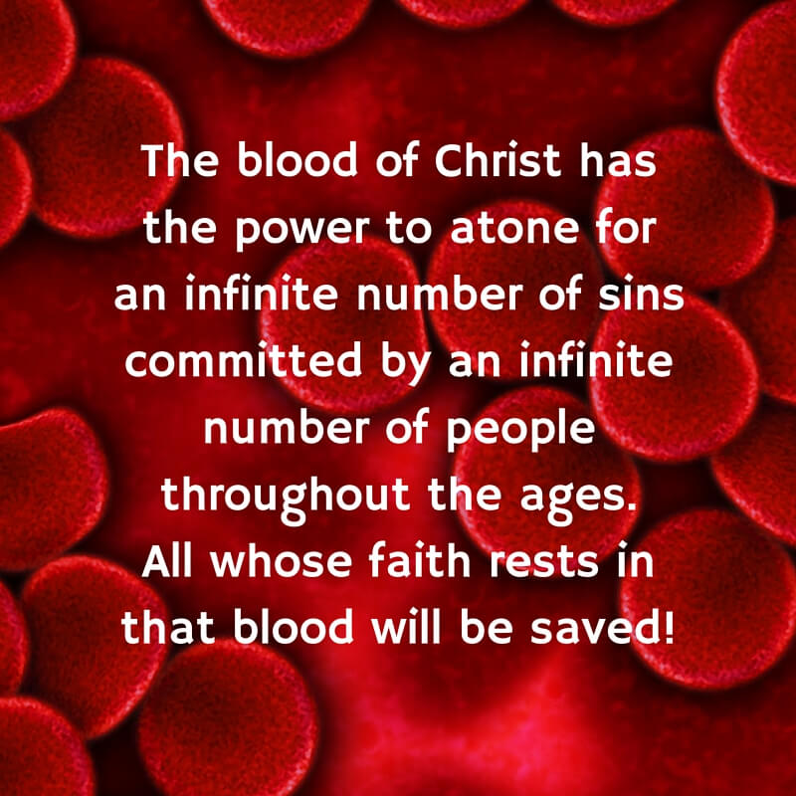

Prayer Targets
  - For Weekly Corporate Prayer
Gideon Warriors | 2020| War Room

Sunday
SUNDAY Prayer Target:
*Protection from censorship and harassment over Ministry Hosts, Employees / Volunteers, Guests, and Outreaches for:
-Pastor Paul Begley
-Pastor Steve with “Tri-State Ministries”
-Pastor Jentezen Franklin with “Free Chapel”
*Worldwide praise and worship; protection; favor; Holy Spirit power

^Sunday FIREWALL:
- Pray for the health and prosperity of all Americans according to 3 John 1:2.
- Pray for a great harvest of souls in America and for laborers to be thrust into the harvest fields according to John 4:35 and Luke 10:2.
- In Jesus’ name, I decree that righteousness thrives in my nation and in every realm of life, and that lawlessness and corruption have no place.
- In Jesus’ name, I decree that LOVE is the greatest aim of all Americans, and that mutual love, honor and respect are shown to all people.

**Fruitfulness in the Body: Love, Joy and Peace and Counsel
-” Blessed are the merciful, for they will be shown mercy” --demonstrates the Gift of Counsel
-Bless the Body of Christ, making it a pillar in Your house, Lord
-Holy Spirit, make us a city of Missionaries, enthusiastic and bubbling over in Your good news

“Thy Kingdom come, Thy will be done, in Earth as it is in Heaven! Jesus Christ is Lord over my nation!”

